Computer Network 1

LAB 4b

Wireshark lab DHCP

Student Name: Alexandre Rousseau

Student ID: 1952001

1. Are DHCP messages sent over UDP or TCP?

DHCP messages are sent over UDP (User Datagram Protocol).

1. 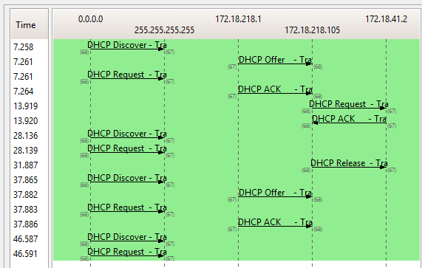Draw a timing datagram illustrating the sequence of the first four-packet Discover/Offer/Request/ACK DHCP exchange between the client and server. For each packet, indicated the source and destination port numbers. Are the port numbers the same as in the example given in this lab assignment?

1. What is the link-layer (e.g., Ethernet) address of your host?

The link-layer address of my host is (00:25:64:e7:3b:2e)

1. What values in the DHCP discover message differentiate this message from the DHCP request message?

The values which differentiate the Discover message from the request message are in “Option: (t=53,l=1) DHCP Message Type”.

1. What is the value of the Transaction-ID in each of the first four (Discover/Offer/Request/ACK) DHCP messages? What are the values of the Transaction-ID in the second set (Request/ACK) set of DHCP messages? What is the purpose of the Transaction-ID field?

Discover – Transaction ID 0x752c8ad1

Offer – Transaction ID 0x752c8ad1

Request – Transaction ID 0x752c8ad1

ACK – Transaction ID 0x752c8ad1

1. A host uses DHCP to obtain an IP address, among other things. But a host’s IP address is not confirmed until the end of the four-message exchange! If the IP address is not set until the end of the four-message exchange, then what values are used in the IP datagrams in the four-message exchange? For each of the four DHCP messages (Discover/Offer/Request/ACK DHCP), indicate the source and destination IP addresses that are carried in the encapsulating IP datagram.

The DHCP client and server both use 255.255.255.255 as the destination address. The client uses source IP address 0.0.0.0, while the server uses its actual IP address as the source.

1. What is the IP address of your DHCP server?

The IP address of the DHCP server is 172.18.218.1

1. What IP address is the DHCP server offering to your host in the DHCP Offer message? Indicate which DHCP message contains the offered DHCP address.

The DHCP server offered the IP address 172.18.218.105 to my client machine. The DHCP message with “DHCP Message Type = DHCP Offer” contained the offered IP.

1. In the example screenshot in this assignment, there is no relay agent between the host and the DHCP server. What values in the trace indicate the absence of a relay agent? Is there a relay agent in your experiment? If so, what is the IP address of the agent?

The router line indicates to the client what its default gateway should be. The subnet mask line tells the client which subnet mask it should be.

1. Explain the purpose of the router and subnet mask lines in the DHCP offer message

In my experiment, the host requests the offered Ip address in the DHCP Request message.

1. In the DHCP trace file noted in footnote 2, the DHCP server offers a specific IP address to the client (see also question 8. above). In the client’s response to the first server OFFER message, does the client accept this IP address? Where in the client’s RESPONSE is the client’s requested address?

The client accepts the IP address given in the offer message within the request message. After being offered the IP address in the offer message, my client sent back a message further requesting that specific IP address.

1. Explain the purpose of the lease time. How long is the lease time in your experiment?

The lease time is the amount of the time the DHCP server assigns an IP address to a client. During the lease time, the DHCP server will not assign the IP given to the client to another client, unless it is released by the client. Once the lease time has expired, the IP address can be reused by the DHCP server to give to another client. In my experiment, the lease time is 8 days.

1. What is the purpose of the DHCP release message? Does the DHCP server issue an acknowledgment of receipt of the client’s DHCP request? What would happen if the client’s DHCP release message is lost?

The client sends a DHCP Release message to cancel its lease on the IP address given to it by the DHCP server. The DHCP server does not send a message back to the client acknowledging the DHCP Release message. If the DHCP Release message from the client is lost, the DHCP server would have to wait until the lease period is over for that IP address until it could reuse it for another client.

1. Clear the bootp filter from your Wireshark window. Were any ARP packets sent or received during the DHCP packet-exchange period? If so, explain the purpose of those ARP packets.

Yes, they appear to be broadcasts sent out by network to build up the known IP addresses by the clients network.